TEST REPORT    Ford Motor (Nanjing) Research and Engineering Co., Ltd.  Asia Pacific Region  Product Development |  | DISPOSE of Copies  (Black Stamped) by  RETAIN Master.Copy  (Red Stamped) thru  GIS Item No
PROGRAM: MY23 CDX707  Milestone: PEC | TO: PMT5  DVP Team: 561/565  REQ ENG:
RQMT ID: RQT-999996-712079  RQMT TITLE: SYNC FUNCTIONAL TESTING_Clock  PRIORITY LEVEL: | DVM ID: 15.00-L-1391  DVM TITLE: starter system engagement time  DVM TYPE:
PART NUMBER: MB6T-18D668-PA  NOTE: | Vehicle: LV612 LV637  (VIN: LVSHNCAC5NH999967)  Location: REC, Nanjing, China
RESULT:

Pass

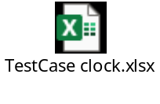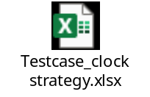

Notes:

Issue List:

JIRA | Summary | Priority
None | None | None

Tool CALIBRATION:
Tool used, calibration Number
TESTED BY:  Huang Xue (xhuang93)  06/20/2021 | APPROVED BY:  06/20/2022

